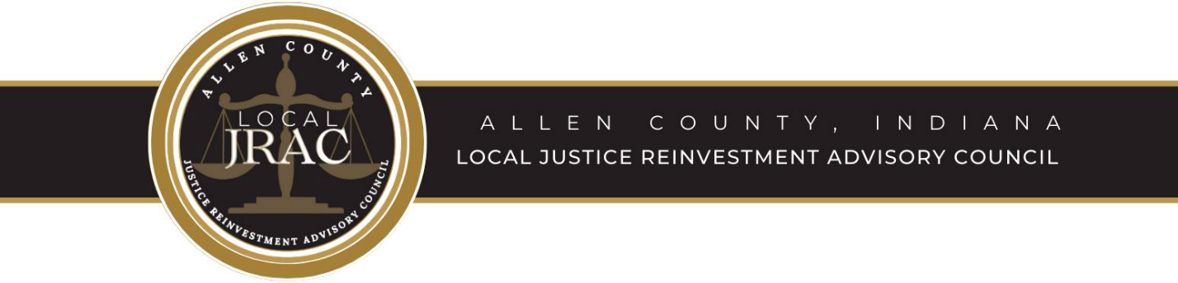

Local JRAC Committee Meeting 4-27-2023

Call to Order

Roll Call

Determination of Quorum

Approval of the Minutes from Previous Meeting

Local JRAC Committee Agenda

- Local JRAC Work Group Report:
- CY2022 Annual Report & Reference Materials (see below)
- EBP Survey Status

- Local JRAC CY2022 Annual Report
- Final Submission 3/31/23
- Review of Reference Materials Identified in Annual Report Process – EBDM and EBP’s

- Senate Enrolled Act 9 Quarter 1 Adult and Juvenile Reports – Review and Approval
- Senate Enrolled Act 9 Quarter 1 Final Survey/Report due May 30, 2023 – DRAFT for review/approval

- Senate Bill 445/PL9 – Update

- Citizen Input Work Group Report – Secretary/Treasurer Bill McGill Chairperson

OLD BUSINESS

NEW BUSINESS

Adjournment

Next Regular Meeting: June 22, 2023 at Noon - Allen County Community Corrections

